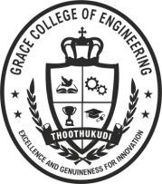

DEPARTMENT OF HUMANITIES AND SCIENCE

INDUCTIONDAY(03.09.2026) AGENDA
VENUE: GRACE AUDITORIUM TIME:10.30AM

- Prayer – Mr. S. Stephen, Vice Chairman, GCOE

- Welcome Address – Dr. M. D. Mohan Gift, Vice Principal, GCOE

- Presidential Address – Mr. C. M. Joshua, Chairman,GCOE

- Inaugural Address – ChiefGuest

- Orientation – Dr. S. Sidhardhan, Principal, GCOE

- Alumni Insights & Present Learner Insights

- HOD’s Introduction

- Introduction of First Year Faculties – Dr. J.Antony Rex Rodrigo,HOD/H&S

Dr. Sivakumar, HOD/ MBA
- Prize Distribution

- Vote of Thanks – Dr. R. Jaqulin Isabella, AP/Tamil

